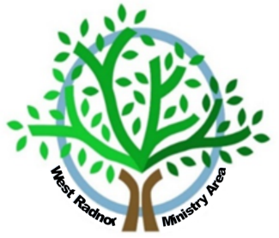
Y Plwyf Gwastedyn
The Parish of Gwastedyn
yn’r Ardal Weinidogaeth Gorllewin Maesyfed
in the West Radnor Ministry Area
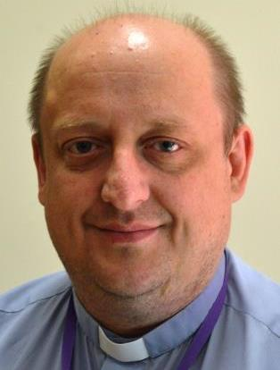

Revd Lance Sharpe MA, CF
Dear Parents & Guardians
I am very proud that our parish has the privilege to have this historic involvement with Rhayader Church in Wales Primary School. As the Priest-in-Charge of the parish I act as a Foundation Governor for the School
I want to assure you that the Parish is fully committed to the wellbeing of your children and wider family too. The children are the future of our community and giving them the best start in life with a great education alongside the values and standards promoted here is of the utmost importance to us. Please be assured of our prayers and practical help for the work of the school in achieving this aim.
Of course, as a Christian church, the parish’s mission is to promote faith in the Lord Jesus Christ and in his teaching as well as the Christian ethos of the school. In that respect, the doors are always open to our churches in the Gwastedyn group for worship, pastoral care and for rites such as christening, confirmation, marriage etc.
We do have a children’s programme with our Messy Church and seasonal services at Christmas such as Christingle or carol services. Please feel free to contact me either in my role as a Governor or as the Parish Priest or telephone our ministry area office.
Pob bendith
Lance
Priest.Gwastedyn@gmail.com Tel: 01597 811565 or 07938 762570
westradnorministryarea@gmail.com Tel: 01597 810770

